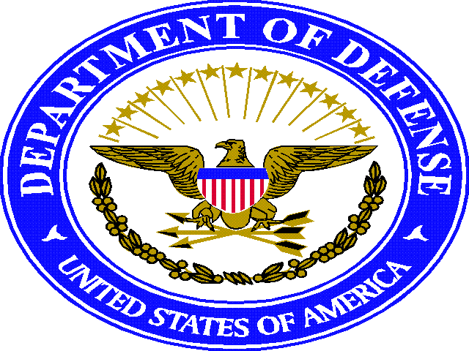
DEPARTMENT OF THE AIR FORCE

HEADQUARTERS 121st AIR REFUELING WING (AMC) (ANG)

7370 minuteman way

COLUMBUS OHIO 43217-1161

12 September 2016
1/2 inch

MEMORANDUM FOR 121 ARW

FROM: 121 ARW/CC

SUBJECT: Environmental, Safety and Health Commitment Statement

1. REFERENCE: Executive Order (E.O.) 13423, AFPD 90-8, and International Organization for Standardization (ISO) 14001

2. The 121st Air Refueling Wing is committed to continued excellence, leadership, stewardship, and conducting our mission in a safe and environmentally responsible manner that will protect human health, natural resources and the environment. In doing so, we will strive to comply with all Federal, State, Local, Executive Orders, Department of Defense, Air Force and Air National Guard environmental, safety and occupational health laws and regulations applicable to the conduct of our mission and strive for continual improvement in our environmental performance as well as providing a safe and healthy workplace. Our Mission:

a. To provide highly trained professionals in support of Federal, State, and Community by:

- Providing timely worldwide air refueling, airlift and support forces-our Federal role
- Protecting life and property, preserving peace, order and public safety-our State role
- Participating in local, state and national programs that add value to America-our community role.

3. This commitment goes beyond compliance with the law and encompasses the integration of sound environmental and safety practices into our daily decisions and activities. We have in the past, and will continue in the future, to pursue a course of responsible stewardship. In support of our environmental, safety and health policy we will:

a. Maintain an effective environmental, safety and health management system, promote the use of safe technologies and operating practices, and remain ready to respond to emergencies in order to improve our overall performance and minimize adverse impacts to installation workers, their families, and the environment.

b. Set goals, measure progress, take corrective action when necessary, and communicate all pertinent information regarding the installation’s operations and it’s environmental, safety and health accomplishments to workers, the community, suppliers, regulators and the public.

c. Investigate and evaluate new and innovative technologies and practices as appropriate and implement and effective pollution prevention program, minimize the generation of wastes, recycle materials otherwise destined to become waste when possible, and dispose of any remaining wastes ion an environmentally responsible manner.

d. Ensure the responsible use of energy throughout the installation, including the adoption of innovative practices and procedures that will conserve energy and improve energy efficiency.

e. Provide regular operation-specific environmental performance reviews and assessments, and develop plans to address actual or potential noncompliance situations.
f. Conduct periodic work-center evaluations to ensure a safe and healthy workplace in accordance with Safety and Health standards.

4. Compliance with this policy is the responsibility of every member of the 121st Air Refueling Wing community in accordance with his/her role and responsibilities in the organization.

MARK D. AUER, Col, OHANG
Commander, 121st Air Refueling Wing

